Public Economics — Practicum 2
Week 2 — all questions
Discussion questions are reproduced from Rosen & Gayer, Public Finance, Chapter 5 (Externalities), 10th Global Edition, pp. 185–189, with all referenced figures reproduced from the same edition. Edition mapping from the practicum sheet: 8th ed. 2, 3a, 3d, 8, 11 = 9th ed. 4, 6a, 6d, 11, 13 = 10th ed. 4, 7a, 7d, 12, 14.

Part A — Discussion Questions (Rosen & Gayer, Chapter 5)

Question 4 — Cassanova's parties
(10th ed. Q4 · 9th ed. Q4 · 8th ed. Q2 — textbook p. 186)
In the following figure, the number of parties that Cassanova gives per month is measured on the horizontal axis, and dollars are measured on the vertical. MCₚ is the marginal cost of providing parties and MBₚ is Cassanova's marginal benefit schedule from having parties.
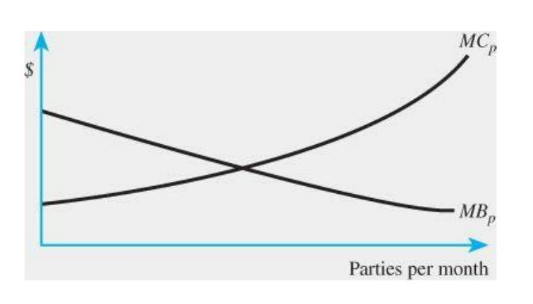
Figure for Question 4 — Rosen & Gayer, 10th Global Edition, p. 186
a. Graphically, show how many parties Cassanova will host.
b. Suppose there is a fixed marginal external benefit, $b, per party to Cassanova's friends. Illustrate this on your graph.
c. What is the socially (no pun intended) optimal level of parties? How could the Social Committee induce Cassanova to throw this number?
d. On your graph, show the optimal subsidy per party and the total amount paid to Cassanova. Who gains and loses under this plan?

Question 7 (parts a and d) — Is the Coase Theorem applicable?
(10th ed. Q7 · 9th ed. Q6 · 8th ed. Q3 — p. 186)
For each of the following situations, is the Coase Theorem applicable? Why or why not?
a. A farmer who grows organic corn is at risk of having his crop contaminated by genetically modified corn grown by his neighbors.
d. Users of the Internet generally incur a zero incremental cost for transmitting information. As a consequence, congestion occurs, and users are frustrated by delays.
Parts b and c are not assigned: b = queen ants vs. eucalyptus pesticides in Silveiras, Brazil; c = illegal Rosewood logging in Madagascar.

Question 12 — Pigouvian tax on commodity X
(10th ed. Q12 · 9th ed. Q11 · 8th ed. Q8 — p. 188)
The private marginal benefit for commodity X is given by 10 − X, where X is the number of units consumed. The private marginal cost of producing X is constant at $5. For each unit of X produced, an external cost of $2 is imposed on members of society. In the absence of any government intervention, how much X is produced? What is the efficient level of production of X? How much does society gain by moving from the inefficient to the efficient level of production? Suggest a Pigouvian tax that would lead to the efficient level. How much revenue would the tax raise?

Question 14 — Cap-and-trade versus an emissions fee
(10th ed. Q14 · 9th ed. Q13 · 8th ed. Q11 — p. 189)
Figure 5.11 demonstrates the efficiency implications of using cap-and-trade versus an emissions fee when costs are higher than expected and marginal social benefits are inelastic. Figure 5.12 does the same thing under the assumption of elastic marginal social benefits. Now consider the case where marginal costs turn out to be lower than anticipated. For both cap-and-trade and an emissions fee, show whether there is too much or too little emissions reduction. Which approach is more efficient when marginal social benefits are inelastic and when they are elastic?
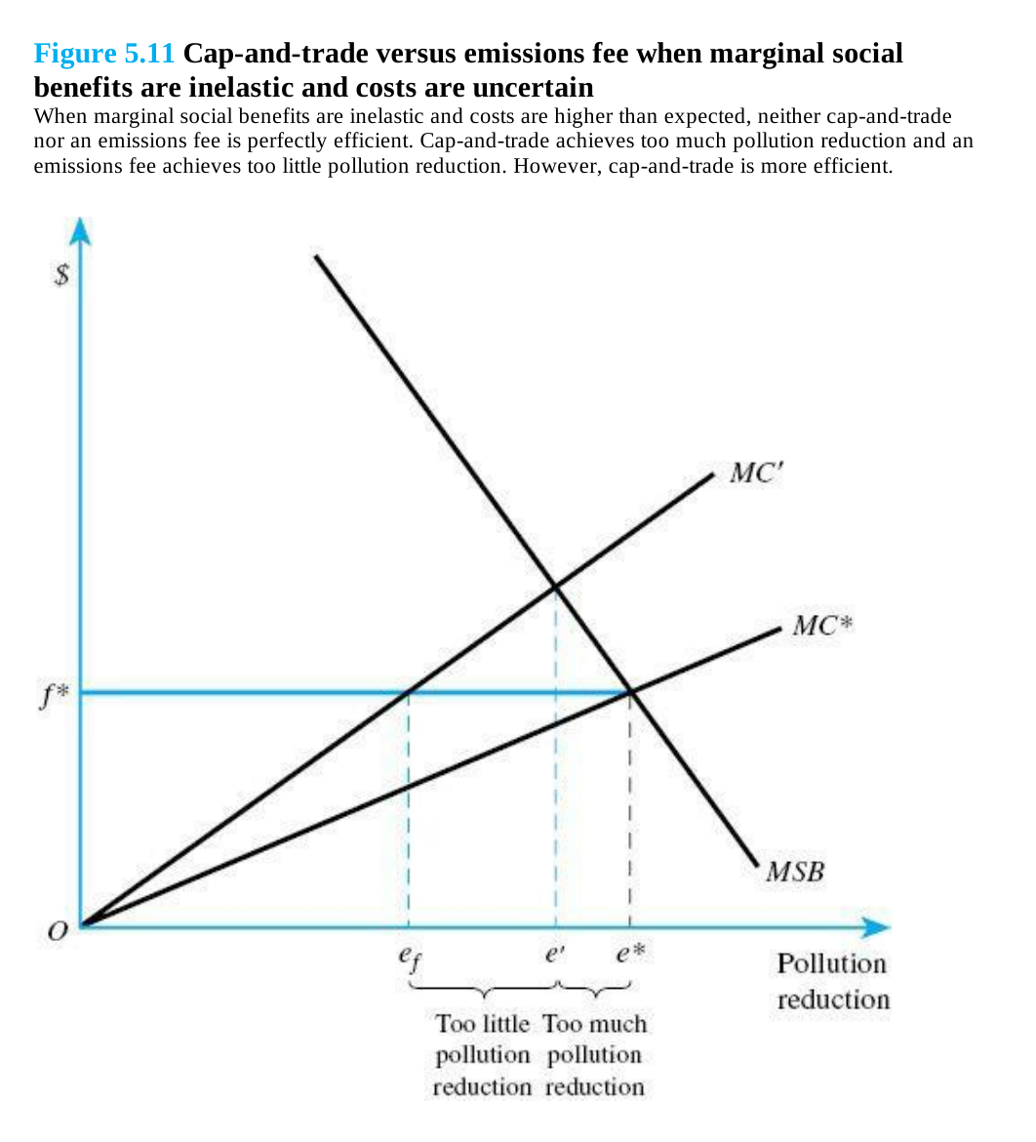
Figure 5.11 — Rosen & Gayer, 10th Global Edition, pp. 171–172
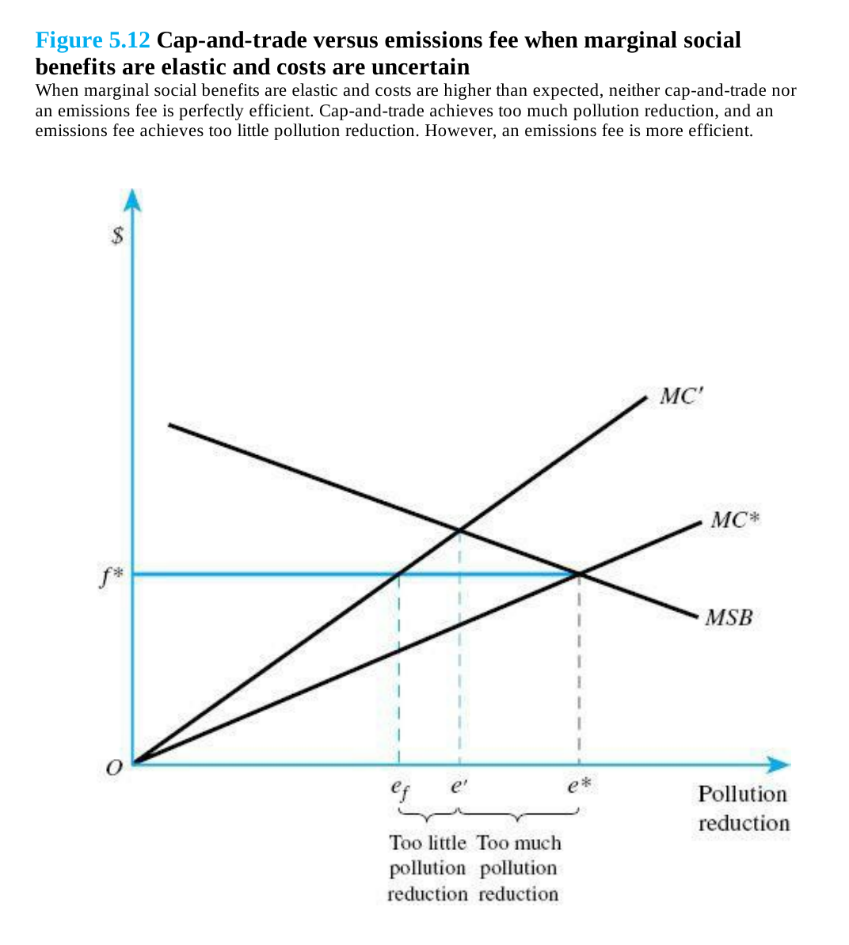
Figure 5.12 — Rosen & Gayer, 10th Global Edition, p. 173

Part B — Additional Exercises

Exercise 2.1 — Anne, Beatrice, and the dog
Anne and Beatrice are neighbours. Beatrice loves pets, and considers adopting either a cat or a dog. Anne is very scared of dogs, and would prefer to stay inside her house permanently if her neighbour would adopt a dog. Consider the following payoffs for Anne and Beatrice.
 | Beatrice: cat | Beatrice: dog
Anne: stay inside | 150 ; 200 | 150 ; 350
Anne: go outside | 450 ; 200 | 0 ; 350

a. If Anne and Beatrice decide independently, what is the Nash equilibrium? Is this an efficient outcome?
b. Suppose Anne and Beatrice can make binding agreements, what will they do?
Now suppose that Anne's payoff of staying inside after Beatrice adopts a dog is 350.
c. If Anne and Beatrice decide independently, what is the Nash equilibrium? Suppose Anne and Beatrice can make binding agreements, what will they do? Explain why this differs from the difference between (a) and (b).

Exercise 2.2 — Paint, emissions, and a Pigouvian tax
A firm produces Q liters of paint at costs 10 + Q². The firm sells its paint at a fixed price of 10 per liter. Emissions, like Volatile Organic Components, are given by the function W = ¼Q. Environmental damage D due to these emissions is estimated at D = 4W².
a. Show in one figure the marginal private benefit, the marginal private cost, and marginal external damage curves.
b. Compare the privately optimal outcome and the socially efficient outcome in terms of output, profits, and damage.
c. What is the level of the Pigouvian tax?
d. Now suppose that the firm reduces its costs to 10 + cQ², where c < 1. Show that the Pigouvian tax increases when c decreases. Explain why.

Exercise 2.3 — The chemical firm and the downstream farmer
A firm located on a riverbank produces Q tons of chemicals, which it can sell at a price of P per ton. Production costs equal ½cQ². Production pollutes the river. The level of pollution in the river is given by W = ½Q. Downstream, a farmer uses the water from the river to irrigate his land. To prevent damage to his crops, he must have clean water. Removing pollution W from the river costs D = 2dW². Assume that P > 0, c > 0, and d ≥ 0.
a. Show in one figure the marginal private benefit, the marginal private cost, and marginal external cost curves.
b. Suppose that the firm has the property rights to the river and that bargaining is costless. What is the outcome of bargaining between the firm and the farmer, in terms of production and payments from one party to the other?
c. How much does social efficiency increase due to the agreement you found under (b), compared to the case without agreement? How does this increase in social efficiency depend on d?
d. Is the outcome of the bargaining different if the farmer has the property rights to the river?

Exercise 2.4 — Cap-and-trade with two firms
Suppose that there are two firms, firm 1 and firm 2. Currently, both firms emit 1000 ton CO₂. The firms differ in their cost of reducing emissions, C(E), where E is the reduction in tons CO₂. These costs, which include both lower production and measures to make production less polluting, are given by, respectively
C₁(E₁) = ⅙(E₁)² C₂(E₂) = ¼(E₂)²
The government has decided that the CO₂ emissions of these firms together should be reduced to 1500 ton. Hence E₁ + E₂ = 500.
a. Suppose the government uses a Cap-and-Trade policy (with the cap at 1500 ton). What is the price that arises on the 'market' for a permit to emit a ton CO₂? (hint: a picture à la Figure 5.10 may help)
b. What is the difference in total cost of reducing emissions between a policy that demands that both firms reduce emissions by 250 ton and the Cap-and-Trade policy?
c. Does it matter how the permits are initially distributed among the two firms?
Now suppose that the cost of CO₂ emissions to society increases. The government considers demanding even lower total emissions of the two companies. Denote the total reduction by R: R = E₁ + E₂. Assume that the marginal external cost of emissions is equal to d euro per ton CO₂, where d > 100.
d. Suppose the government uses a Cap-and-Trade policy. What is the socially efficient Cap on total emissions? How does the price that arises on the 'market' for a permit to emit a ton CO₂ depend on d?
e. Now suppose the government demands that both firms reduce their emissions by the same amount (E₁ = E₂ = ½R). What is the socially efficient level of emissions? Explain the difference with question (d).
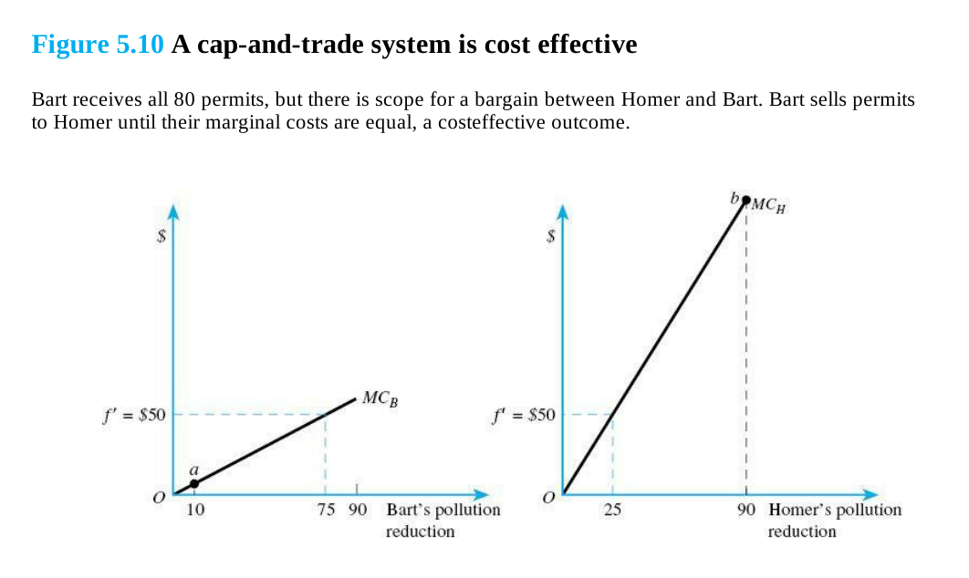
Figure 5.10 — the figure the hint in part (a) refers to (Rosen & Gayer, 10th Global Edition, pp. 167–168)

Exercise 2.5 — Positive externalities of university education
University education has positive externalities. Suppose that total demand for university education in a country is given by P = 100 − 2q, where P is the price of university education and q the total quantity of university education. Furthermore, marginal external benefits of university education are given by MEB = 25 − ½q. Marginal cost of university education is constant and equal to 20, which is also the price of university education when the government does not intervene in this market.
a. Derive the socially efficient level of university education, and the level of university education that arises without government intervention.
b. What are the total expenditures on a Pigouvian subsidy on university education?
Now suppose that the government decides to provide university education for free (= provides a subsidy of 20 per unit).
c. Calculate the efficiency gain or loss that arises if university education is provided for free, compared to the case where there is no government intervention at all. Explain why efficiency increases or decreases. (Hint: draw a figure)
Now suppose that the private returns to education increase, leading demand to change to P = a − 2q, where a > 100.
d. Derive how the Pigouvian subsidy depends on a. Explain.

Exercise 2.6 — Traffic jams: bike or car
Consider a town with 5000 identical citizens. Each citizen owns a bike and a car. Each citizen must decide whether to travel to work by bike or by car. Travelling by bike would take m_f = 40 minutes. Travel time by car depends on whether there are traffic jams. A traffic jam arises when more than 500 citizens take the car. Hence, travelling by car would take m_c = 25 minutes if the number of cars C ≤ 500. Travelling by car would take m_c = 25 + (1/100)(C − 500) minutes if C > 500. Assume that each citizen wants to minimise own travel time and that every citizen decides independently whether to travel by bike or by car.
a. Determine the number of citizens that travel by car in the Nash equilibrium.
b. Prove that in the Nash equilibrium, inefficiently many citizens travel by car. Explain why this happens.
A politician argues that traffic jams can be reduced by investing in road capacity. The politician proposes to increase the number of lanes on the road, such that traffic jams only arise if there are more than 2000 cars on the road. After this investment, travel time by car would be m_c = 25 minutes if the number of cars C ≤ 2000 and m_c = 25 + (1/100)(C − 2000) if C > 2000. Another politician argues that it would be better to invest in better bike lanes instead. At similar investment cost, it would be possible to reduce travel time by bike to m_f = 35 minutes.
c. Calculate the reduction in total travel time for each of these proposals. Compare with the outcomes under (a) and explain.
Other types of government interventions are possible. Consider the choice between a Pigouvian subsidy for citizens who travel by bike and a Pigouvian tax for citizens who travel by car.
d. Suppose we only care about efficiency in citizens' choice between travel by bike or by car. Discuss which of these two interventions is better and why.

Exercise 2.7 — Sheep on the common field (extra practice)
This is an old exam exercise with propositions, which can be true or false. It will not be discussed in the tutorial, but serves as extra practice material.
A village has 10 identical rich inhabitants, who all have 1000 euro they do not need to spend directly. Every inhabitant has two options: saving the money or buying a sheep for 1000 euro. Saving yields an interest rate of 10 percent per year. A sheep can be placed on the field next to the village, and can be sold after a year to a butcher. Taking care of a sheep is costless. The price P that an inhabitant gets for his sheep after a year depends on the total number of sheep S on the field:
P = 1700 − 100S
The field is part of the village, but has no owner, and can only be used for holding sheep. Inhabitants of the village decide independently between saving and buying a sheep.
a. The Nash-equilibrium number of sheep is 7.
b. The socially efficient number of sheep is 3.
c. The 'tragedy of the commons' arises when resources are non-rival and excludable.
Suppose there is an eleventh inhabitant of the village. This person is poor and does not have 1000 euro to save. The marginal utility of income of the poor inhabitant is higher than the marginal utility of income of the 10 rich inhabitants. The social welfare function of the village is equal to the sum of utilities of all inhabitants (additive). Suppose that the poor inhabitant finds a document that proves that he actually owns the field in the village. This means that he now can ask for a payment from rich inhabitants who want to put a sheep on the field.
d. The poor inhabitant can earn maximally 900 euro per year with exploiting the field.
e. Social welfare is higher after the poor inhabitant becomes owner of the field.
f. If the social welfare function is additive, then a Pareto-improvement always leads to higher social welfare.

Worked answers to all of the above are in the original practicum sheet ("exercises week 2.pdf", pp. 6 onwards).

